**

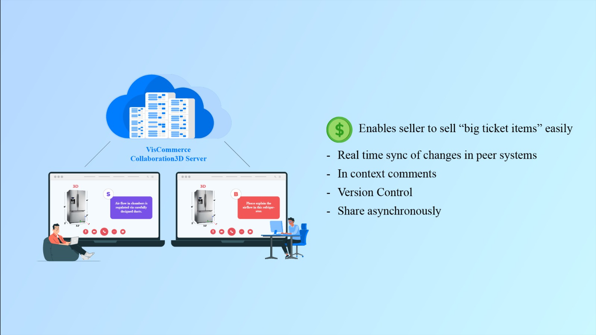

**Subject: Revolutionize Big Ticket Sales with VisCommerce's Collaborative 3D Store Planner**

Dear [Recipient's Name],

I trust this email finds you in good health. I'm excited to introduce you to the game-changing capabilities of VisCommerce's 3D Store Planner, particularly its Collaborative 3D Server, which promises to reshape how we approach big ticket item sales.

This advanced feature not only simplifies the selling process for sellers but also enhances real-time collaboration, version control, and seamless communication across peers.

In the realm of retail, particularly when dealing with high-value items, offering a streamlined and collaborative sales approach is essential. The Collaborative 3D Server within VisCommerce's 3D Store Planner empowers us to do just that, elevating the sales process and delivering an unparalleled level of convenience.

**Here's how this feature transforms the way we sell big ticket items:**

* **Real-Time Sync:** The Collaborative 3D Server enables real-time synchronization of changes across peer systems. Sellers can seamlessly update product details, configurations, and layouts, ensuring everyone is on the same page and providing customers with accurate and up-to-date information.
* **Peer Collaboration:** With in-context comments and asynchronous sharing, our team can collaborate seamlessly on a shared project. This means that peers can discuss changes, suggest improvements, and communicate ideas directly within the 3D Store Planner interface, enhancing teamwork and decision-making.
* **Version Control:** The version control feature ensures that every iteration of a project is tracked. This not only promotes accountability but also allows us to review and access previous versions, ensuring a comprehensive history of changes and decisions made.
* **Enhanced Selling Experience:** The Collaborative 3D Server simplifies the selling process for big ticket items. Sellers can easily customize layouts, configurations, and designs to match customer preferences, enhancing their experience and increasing the likelihood of a successful sale.
* **Efficient Customer Communication:** The ability to share projects asynchronously means we can collaborate effectively with customers as well. Whether it's sharing design proposals or discussing options, this feature ensures timely and effective communication, even across different time zones.

The power of the Collaborative 3D Server lies in its ability to transform the selling process into a dynamic and collaborative experience. This feature not only boosts efficiency but also strengthens our ability to cater to customer needs, ensuring their satisfaction and loyalty.

If you're interested in exploring the capabilities of the Collaborative 3D Server further, I'd be thrilled to provide additional insights or arrange a demonstration.

The VisCommerce 3D Store Planner is truly revolutionizing how we approach big ticket item sales, and I'm excited to see the impact it can have on our business.

Thank you for your time, and I eagerly await your thoughts.

Best regards,